Machine Learning for Question Type Classification and Clustering on the dr-tulu-sft-data Dataset

Karthik Chowdary pallapothu

Faculty of Data Science
Coventry University
Karthikpallapothu99@gmail.com

Abstract-The rapid growth of text-based interactions on digital platforms has created a need for automated systems capable of understanding and categorizing user-generated content. In this study, we explore machine learning (ML) techniques for classifying question types and uncovering natural groupings within the dr-tulu-sft-data dataset, which contains 13,062 labeled examples. The dataset features three question types: exact_answer, long_form, and short_form. We implemented four supervised classifiers: Support Vector Machine (SVM), K-Nearest Neighbors (KNN), Logistic Regression (LogReg), and Naive Bayes (NB), using TF-IDF features. Additionally, we applied unsupervised clustering methods, including K-Means and Hierarchical Clustering, on SVD-reduced TF-IDF representations to explore latent structures. SVM achieved the highest classification accuracy of 83.8%, demonstrating strong performance on high-dimensional textual data. KNN performed poorly due to sparsity sensitivity, while Logistic Regression and Naive Bayes provided competitive alternatives. Clustering revealed meaningful groupings, with K-Means achieving a silhouette score of 0.47, indicating reasonable separation among clusters. These results highlight the utility of combining supervised and unsupervised methods for understanding complex textual datasets and provide a foundation for improved question-answering and conversational AI systems.
Link .https://huggingface.co/datasets/rl-research/dr-tulu-sft-data
- Introduction
Automated understanding of textual data is increasingly critical in the age of digital information. Platforms such as online forums, Q&A systems, and chatbots generate vast volumes of questions and queries, necessitating efficient systems to classify and structure content for downstream applications. Machine learning (ML) offers effective tools for addressing these challenges, including classification algorithms for supervised learning and clustering techniques for unsupervised exploration of natural groupings in data.
In this study, we focus on the dr-tulu-sft-data dataset, which contains diverse questions from conversational AI interactions, categorized into three types: exact_answer, long_form, and short_form. Classifying these questions is essential for automated tutoring systems, conversational agents, and information retrieval, as it allows for tailored responses based on the type of question. Furthermore, clustering can reveal latent patterns in question phrasing and semantics, offering insight into dataset structure beyond predefined labels.
Previous studies have demonstrated the effectiveness of various algorithms for text classification. Support Vector Machines (SVM) are well-suited for high-dimensional textual data due to their ability to find optimal separating hyperplanes. K-Nearest Neighbors (KNN) leverages local similarity but can struggle with sparse TF-IDF representations. Logistic Regression provides probabilistic interpretations and scales well to multi-class problems. Naive Bayes (NB) is often effective for text but assumes feature independence, which may limit performance in highly correlated TF-IDF vectors. Unsupervised approaches such as K-Means and Hierarchical Clustering, particularly when combined with dimensionality reduction techniques like Truncated Singular Value Decomposition (SVD), can reveal natural groupings of questions in latent semantic space.
The aim of this study is twofold: first, to evaluate the performance of multiple ML algorithms in classifying question types, and second, to explore natural clusters within the dataset to better understand question structure and relationships.
- Problem and Dataset Description
The primary task in this study is multi-class question type classification. The dataset, dr-tulu-sft-data, consists of 13,062 examples, each with the following attributes:
- id: unique identifier for the question.
- source_id: identifier for the source dataset.
- question: textual content of the question.
- source: source platform or origin of the question.
- type: label indicating the expected answer type (exact_answer, long_form, short_form).
- num_tool_calls: number of tool calls used in generating the answer.
- tokenized_length: length of tokenized question.
- conversations: conversation context associated with the question.
The distribution of question types is uneven, with long_form questions representing the largest proportion, followed by exact_answer and short_form. This imbalance presents challenges for classification models, particularly in predicting minority classes. Accurate classification has practical significance for conversational AI, as correctly identifying question type informs response generation strategies and improves user experience.
Clustering the questions serves an exploratory purpose, revealing how questions naturally group based on content, phrasing, and semantics. Dimensionality reduction via SVD is applied to mitigate the curse of dimensionality associated with TF-IDF features and to facilitate tractable clustering.

- Methods

3.1 Preprocessing and Feature Extraction
The raw text in the question field was preprocessed using TF-IDF vectorization, capturing term frequency weighted by inverse document frequency. The TF-IDF matrix was limited to 5000 features to balance information retention and computational efficiency. A train-test split of 70:30 was applied with stratification to preserve the distribution of question types.
For clustering, Truncated SVD was used to reduce TF-IDF vectors to 50 dimensions. This transformation retains major latent semantic structures while enabling efficient computation for K-Means and Hierarchical Clustering.

3.2 Classification Algorithms
- Support Vector Machine (SVM)
SVM with a linear kernel was employed due to its strong performance on high-dimensional sparse text data.
- K-Nearest Neighbors (KNN)
KNN with k=5 was used to assess local similarity-based classification. KNN performance is known to degrade with sparse high-dimensional vectors like TF-IDF.
- Logistic Regression (LogReg)
Multi-class Logistic Regression provides a probabilistic framework suitable for this three-class problem.
- Naive Bayes (NB)
Multinomial Naive Bayes was applied, leveraging term occurrence frequencies while assuming feature independence.
Evaluation metrics: Accuracy, precision, recall, F1-score, and confusion matrices were computed to assess model performance for each class.

3.3 Clustering Algorithms

K-Means Clustering
K-Means was applied on the 50-dimensional SVD-reduced features. The number of clusters was set to 3, corresponding to the known question types. The silhouette score was calculated to evaluate cluster separation.
- Hierarchical Clustering
Agglomerative clustering with Ward linkage was performed on the SVD-reduced features. The dendrogram was truncated to 20 levels to improve readability and interpretability.

- Experimental Results

4.1 Classification Results
The classification performance for each model is summarized below:
SVM
- Accuracy: 83.8%
- exact_answer: Precision 0.88, Recall 0.94, F1 0.91
- long_form: Precision 0.86, Recall 0.87, F1 0.86
- short_form: Precision 0.71, Recall 0.62, F1 0.66
- Confusion matrix indicates most errors involve short_form misclassified as long_form.
Logistic Regression
- Accuracy: 83.7%
- Slightly lower F1 for short_form compared to SVM, otherwise comparable.
Naive Bayes
- Accuracy: 74.3%
- Performs well on long_form (high recall) but struggles with exact_answer and short_form.
KNN
- Accuracy: 34.0%
- Poor performance overall, heavily biased toward over-predicting long_form.
Table 1: Classification Accuracy Summary
Model | Accuracy
SVM | 0.838
Logistic Regression | 0.837
Naive Bayes | 0.743
KNN | 0.340
Interpretation:
SVM and Logistic Regression are suitable for this multi-class, high-dimensional text dataset. Naive Bayes works reasonably but is affected by correlated features. KNN is unsuitable due to sparsity in TF-IDF vectors.

4.2 Clustering Results
K-Means
- Silhouette score: 0.470
- Reasonable separation observed among the three clusters in 2D SVD projections.
- Clusters largely correspond to question types, although some overlap exists, particularly between short_form and long_form.
Hierarchical Clustering
- Truncated dendrogram reveals meaningful question groupings, which can be interpreted for content similarity and type overlap.
- Dimensionality reduction was essential for computational feasibility and interpretability.
- Discussion
The results highlight several key insights:
- Supervised Learning:
  - High-dimensional TF-IDF features are effectively handled by SVM, which outperformed other models.
  - Logistic Regression is competitive and interpretable, providing a practical alternative.
  - Naive Bayes shows class-specific strengths but is limited by feature dependencies.
  - KNN struggles with sparse TF-IDF vectors, confirming theoretical expectations.
- Class-Specific Performance:
  - short_form questions remain the most challenging to classify, likely due to lower sample representation and brevity.
  - exact_answer and long_form questions achieve high precision and recall, suggesting models can capture consistent textual patterns.
- Unsupervised Learning:
  - SVD-reduced features allow efficient clustering while retaining latent semantics.
  - K-Means clusters correspond reasonably well to true question types, evidenced by the silhouette score of 0.47.
  - Hierarchical clustering provides interpretability, revealing content similarity patterns that may inform future dataset curation or automated labeling.
- Implications for Conversational AI:
  - Combining classification and clustering enables both precise prediction of question type and exploratory insights into question structure.
  - Such pipelines could improve response selection, dataset balancing, and conversational modeling in AI systems.
- Limitations:
  - TF-IDF features, while effective, ignore word order and contextual semantics.
  - Minority class (short_form) is underrepresented, limiting predictive performance.
  - Clustering evaluation relies on silhouette scores, which may not fully capture semantic coherence.
- Future Work:
  - Use transformer-based embeddings (e.g., BERT, RoBERTa) for richer contextual representations.
  - Explore semi-supervised or hybrid models combining classification and clustering.
  - Augment minority classes to improve short_form prediction.
  - Evaluate clustering using alternative metrics (e.g., Calinski-Harabasz, Davies-Bouldin) for robustness.

6. Figures and Visualization
Figure 1: Confusion matrices for SVM, KNN, Logistic Regression, and Naive Bayes demonstrate model-specific strengths and weaknesses.
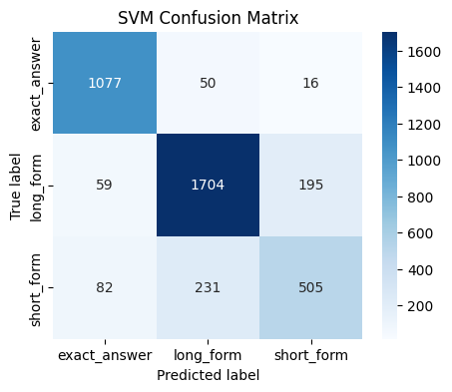
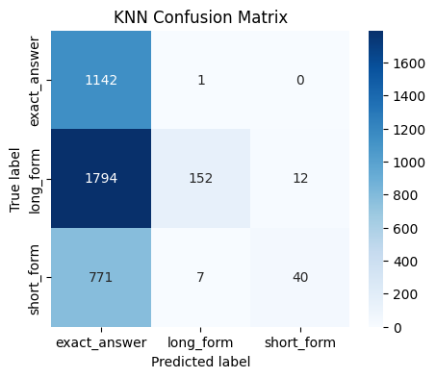
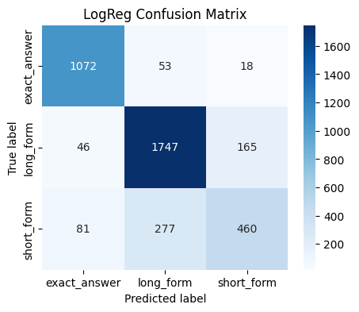
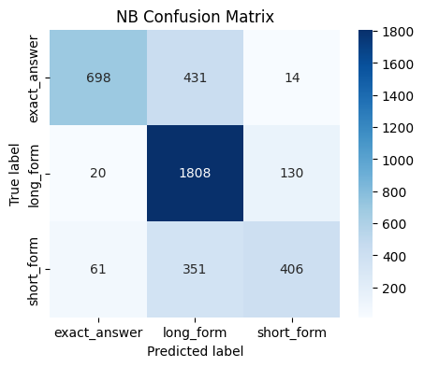
Figure 2: 2D scatter plot of K-Means clusters in SVD-reduced space shows reasonable separation between question types.
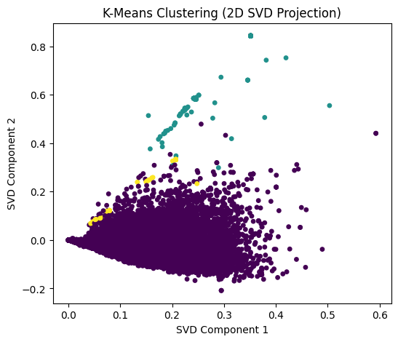
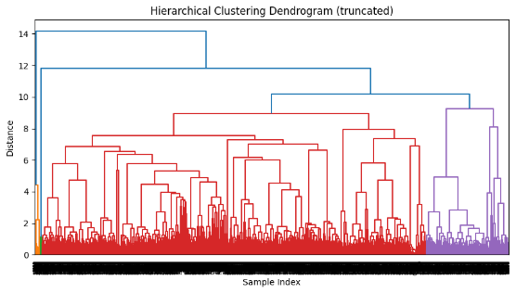
Figure 3: Truncated hierarchical dendrogram illustrates groupings and content similarities across questions.
- Conclusion
This study applied multiple machine learning techniques to classify question types and uncover natural groupings in the dr-tulu-sft-data dataset. SVM achieved the highest accuracy of 83.8%, confirming its suitability for high-dimensional text classification. Logistic Regression provided a competitive alternative, while Naive Bayes showed moderate performance and KNN was ineffective due to TF-IDF sparsity. Clustering analysis with SVD-reduced features revealed meaningful patterns, with K-Means achieving a silhouette score of 0.47 and hierarchical clustering offering interpretability of content similarities. The results emphasize the importance of combining supervised and unsupervised approaches for understanding textual data, with potential applications in conversational AI, automated tutoring, and information retrieval systems. Future work will explore transformer-based embeddings, hybrid models, and enhanced handling of minority classes to further improve classification and clustering performance.
- References
- Cortes, C., & Vapnik, V. (1995). Support-vector networks. Machine Learning, 20(3), 273–297.
- Cover, T., & Hart, P. (1967). Nearest neighbor pattern classification. IEEE Transactions on Information Theory, 13(1), 21–27.
- McCallum, A., & Nigam, K. (1998). A comparison of event models for Naive Bayes text classification. AAAI-98 Workshop on Learning for Text Categorization.
- Jolliffe, I. T. (2002). Principal Component Analysis. Springer.
- Langley, P. (2000). Crafting papers on machine learning. Retrieved from http://www.machinelearning.ru/wiki/images/0/07/Langley00crafting.pdf

Appedices
# Full ML pipeline for dr-tulu-sft-data
from datasets import load_dataset
import pandas as pd
from sklearn.model_selection import train_test_split
from sklearn.feature_extraction.text import TfidfVectorizer
from sklearn.svm import SVC
from sklearn.neighbors import KNeighborsClassifier
from sklearn.linear_model import LogisticRegression
from sklearn.naive_bayes import MultinomialNB
from sklearn.metrics import accuracy_score, classification_report, confusion_matrix, silhouette_score
from sklearn.cluster import KMeans, AgglomerativeClustering
from sklearn.decomposition import TruncatedSVD
from scipy.cluster.hierarchy import dendrogram, linkage
import matplotlib.pyplot as plt
import seaborn as sns

# 1. Load dataset
ds = load_dataset("rl-research/dr-tulu-sft-data")
df = ds["train"].to_pandas()

# 2. Inspect columns
print(df.columns)

# 3. Define features and labels
X = df['question'] # input text
y = df['type'] # target class

# 4. Train-test split with stratification
X_train, X_test, y_train, y_test = train_test_split(
X, y, test_size=0.3, random_state=42, stratify=y
)

# 5. TF-IDF vectorization
vectorizer = TfidfVectorizer(max_features=5000)
X_train_vec = vectorizer.fit_transform(X_train)
X_test_vec = vectorizer.transform(X_test)

# 6. Classification
# SVM
svm = SVC(kernel="linear")
svm.fit(X_train_vec, y_train)
y_pred_svm = svm.predict(X_test_vec)

# KNN
knn = KNeighborsClassifier(n_neighbors=5)
knn.fit(X_train_vec, y_train)
y_pred_knn = knn.predict(X_test_vec)

# Logistic Regression
logreg = LogisticRegression(max_iter=1000)
logreg.fit(X_train_vec, y_train)
y_pred_log = logreg.predict(X_test_vec)

# Naive Bayes
nb = MultinomialNB()
nb.fit(X_train_vec, y_train)
y_pred_nb = nb.predict(X_test_vec)

# 7. Evaluation - print results
models_preds = {
"SVM": y_pred_svm,
"KNN": y_pred_knn,
"LogReg": y_pred_log,
"NB": y_pred_nb
}

for name, y_pred in models_preds.items():
print(f"\n--- {name} ---")
print("Accuracy:", accuracy_score(y_test, y_pred))
print("Classification Report:\n", classification_report(y_test, y_pred))
print("Confusion Matrix:\n", confusion_matrix(y_test, y_pred))

# ===============================================
# 8. Confusion Matrix Plots
# ===============================================
classes = y.unique()

def plot_confusion_matrix(y_true, y_pred, title):
cm = confusion_matrix(y_true, y_pred, labels=classes)
plt.figure(figsize=(5,4))
sns.heatmap(cm, annot=True, fmt='d', xticklabels=classes, yticklabels=classes, cmap='Blues')
plt.ylabel('True label')
plt.xlabel('Predicted label')
plt.title(title)
plt.show()

for name, y_pred in models_preds.items():
plot_confusion_matrix(y_test, y_pred, f'{name} Confusion Matrix')

# ===============================================
# 9. Clustering
# ===============================================
# Vectorize all questions for clustering
X_all_vec = vectorizer.transform(df["question"])

# --- SVD for dimensionality reduction ---
svd = TruncatedSVD(n_components=50, random_state=42)
X_svd = svd.fit_transform(X_all_vec)

# --- K-Means ---
n_clusters = y.nunique()
kmeans = KMeans(n_clusters=n_clusters, random_state=42)
km_labels = kmeans.fit_predict(X_svd)
sil_km = silhouette_score(X_svd, km_labels)
print("\nK-Means Silhouette Score:", sil_km)

plt.figure(figsize=(6,5))
plt.scatter(X_svd[:,0], X_svd[:,1], c=km_labels, cmap='viridis', s=15)
plt.xlabel('SVD Component 1')
plt.ylabel('SVD Component 2')
plt.title('K-Means Clustering (2D SVD Projection)')
plt.show()

# --- Hierarchical Clustering ---
linked = linkage(X_svd, method='ward')
plt.figure(figsize=(10, 5))
dendrogram(linked, truncate_mode='level', p=20)
plt.title('Hierarchical Clustering Dendrogram (truncated)')
plt.xlabel('Sample Index')
plt.ylabel('Distance')
plt.show()

